**Tutorial – 11: Indexing & Hashing**

1. Consider the below B+ tree

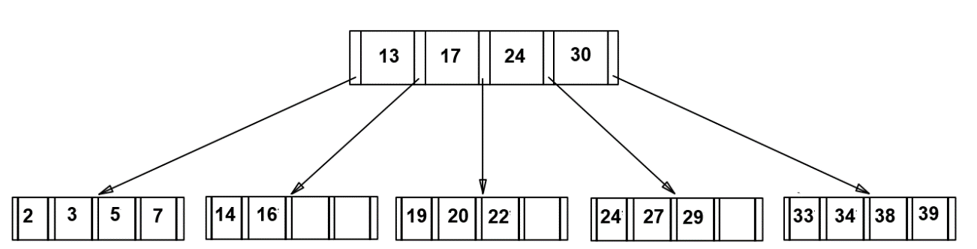

Perform the following operations on the above tree in the order as given below where the upper limit to the degree (no. of children or pointers) of the tree is 5 (i.e. no. of search key values in a node that can be allowed <= 4). During insertion, assume that splitting operation involves placing first  in the original node. During deletion, assume that redistribution operation is the preferred choice over merge siblings operation:

1. Insert 23
2. Insert 8
3. Delete 19
4. Delete 20
5. Delete 24

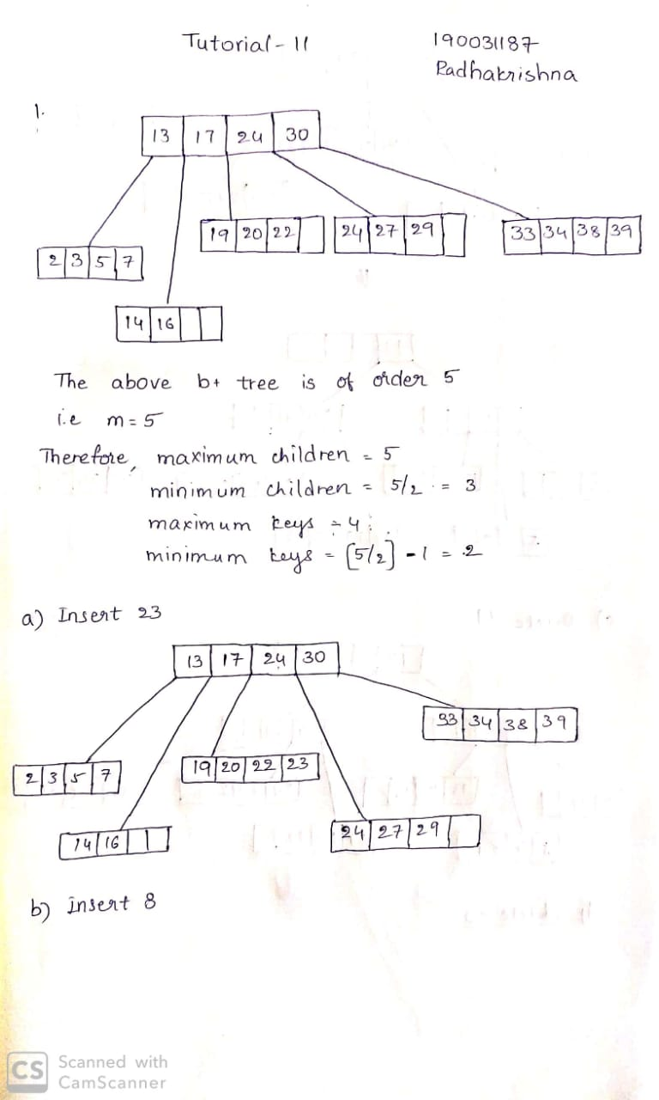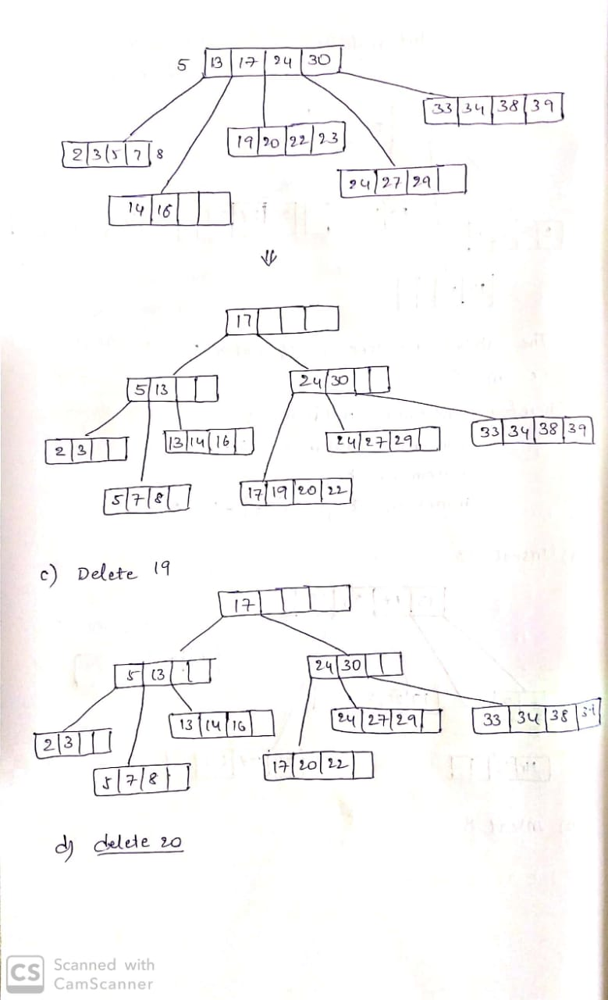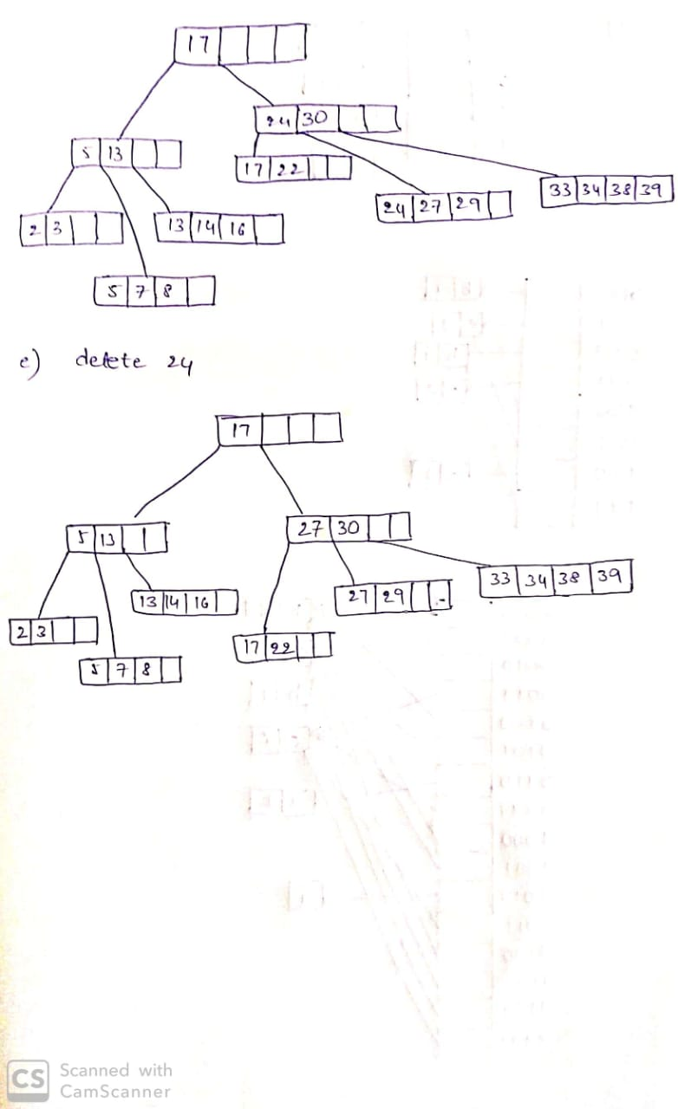

1. Suppose that we are using extendible hashing on a file that contains records with following search-key values: a [000110], b [111100], c [010111], d [010000], e [101001], f [010111], g [101001],h [011010], i [011010], j [011010], k [001110]. Consider an extendible hash structure where buckets can hold up to two records. Initially the structure is empty. Show the extendible hash structure after these records (in the order shown above) have been inserted.

